You task is to implement .net core API to power this screen. Important **you don’t have to create the UI**, only the API with enough endpoints/methods to allow this UI to be created.

For this test you are required to use ASP.NET core, Entity Framework Core and all the frameworks listed below. In some cases folks will decide to use something else, in fact we need you to use the below because we are judging if you can learn new technologies too

* Create SQL Server database
* Define EF Core to create DbContext for this database
* Create API controller that uses Service class (service class uses Repository class)
* Use NLog ( or other similar framework) for logging
* Use Autofac ( or other similar framework for ) for dependency injection
* Use Automapper for mapping entity to viewmodel
* Write unit test for this service

 You can see the full image here. [**https://tinyurl.com/wg394vn**](https://tinyurl.com/wg394vn)

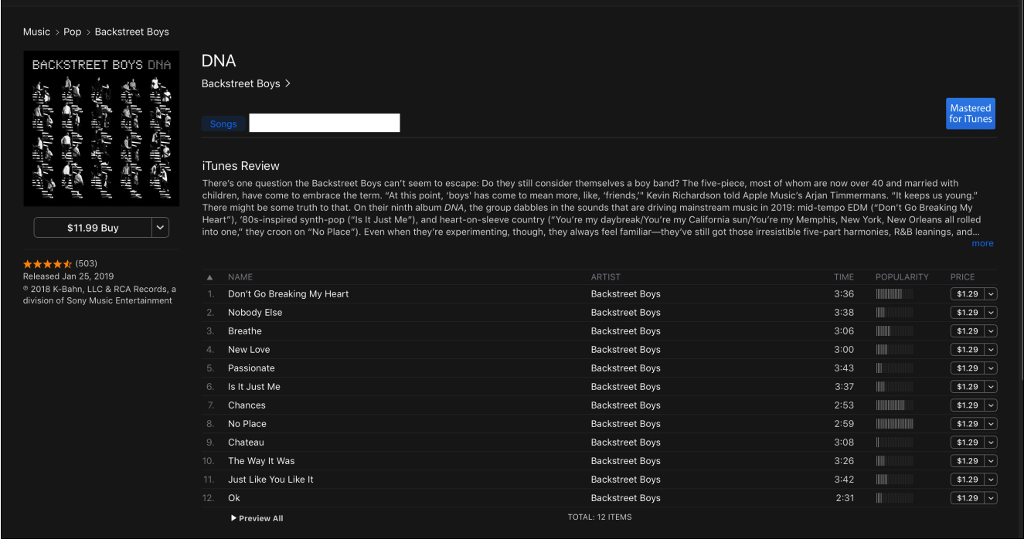

Once you have your solution, upload it to Github where you can get a free account and send us a link to your repo.